Good Robot, Good Robot! Should A.I. systems (or robots) have rights?

Derek Wang

Computer Science

ITCS 3688: Computers and Their Impact on Society

Dr. Jason Karp

07/08/2022

INTRODUCTION
Introduction to the topic
A.I. also known as Artificial Intelligence is a term that was coined by Stanford Professor John McCarthy in 1955(Manning, 2022), Professor McCarthy defined A.I. as the science and engineering of making intelligent machines. Another definition for A.I. in Oxford dictionary is the study and development of computer systems that can copy intelligent human behavior. Currently A.I. is a rapidly developing field of technology that “is integrated in our lives and in all fields of work”(Benefits & risks of artificial intelligence).
History of the topic within society including ethical issues
A.I. was just a concept by Alan Turing, a young British polymath who wrote Computing Machinery and Intelligence in 1950. A.I. first became part of our society in 1951 when the first working AI programs were written to run on the Ferranti Mark 1 machine of the University of Manchester. In the field of A.I as an academic discipline came about in 1956, many scientists and researchers were optimistic about A.I, but fell in disappointment due to technology constraints and fell into a period of time known as an AI winter where AI lost its funding. Now technology has rapidly advanced in the current era. Renewed interest in artificial intelligence in 2012, specifically in machine learning A.I brought in funding and investment by corporations. The success of machine learning A.I brought upon the A.I spring a period where the field of AI is in-demand.
Relevance to society related to ethics
As the popularity and use of A.I. become substantial to current society and humanity, many are becoming concerned of A.I. position in society due to an A.I. named “Sophia by Hanson Robotics was granted citizenship as a non-human by Saudi Arabia, making Saudi Arabia the first country to grant citizenship to a robot”(Beno 2019) in October 2017. Sophia became the first robot citizen of the world even though Sophia is a robot with no consciousness nor does Sophia have the ability to simulate emotions. Sophia is a just basic A.I. that uses dialogue generated via a decision tree integrated with unique outputs which makes Sophia seem human. The topic of Sophia gaining citizenship event further ignited the issues of robotics rights, “especially in the case of Sophia where the robot has more privileges than female citizens in Saudi Arabia”(Beno 2019). A.I. currently has no regulation due to rapid development of technology and that “Using robots to fill in the shrinking workforce, having robots as personal companions and care for children and the elderly, and help with healthcare services”(Beno 2019) is affecting and replacing people's jobs in these industry sectors. This fact that robots are replacing jobs has caused many to fear the development of A.I. will affect their livelihood. There is also the fact that many types of A.I. require data collection to improve these types of A.I. often collect data without users knowledge, which is an issue of data privacy for many people.
Statement of the problem or thesis statement
As A.I continues to integrate deeper in today's society, the lack of A.I. regulation is an apparent issue and controversy of A.I. and the debate of should A.I. having rights is a subject that must be addressed. If one day robots gain self awareness and the ability to reason, should they be entitled to moral and legal rights similar to humans? The fact that A.I has no regulation is an alarming fact because “if the programmer forgets about security and safety when designing A.I., then it can be devastating, even catastrophic, also if the A.I. was not programmed properly causing it to misunderstand your instruction can create a dreadful outcome”(Benefits & risks of artificial intelligence). Because even if some people deny Artificial Intelligence and they attack current existing robots like “kicking robot police resources over or knocking down delivery bots in hopes of reclaiming a feeling of security or superiority.”(Marko 2019). The fact that A.I has long been part of our society and will continue to transform the world and our lives is unavoidable. The benefits of A.I. in society are considerable and positive in many ways like replacing dangerous jobs with A.I. automations, Improving medical procedures using specialized robots for minimal invasive operations, and etc..

LITERATURE REVIEW
Literature on the topic - AI SAFETY - BENEFITS & RISKS OF ARTIFICIAL INTELLIGENCE -Peer
A.I. aka Artificial Intelligence can be found in anything from search algorithms programs to voice assistants to autonomous weapons. A.I. is integrated in our lives and in all fields of work. There are many misconceptions about A.I. and myths created about the future of A.I.. There are three categories of AI, Artificial Narrow Intelligence (ANI) aka Narrow AI (weak AI), Artificial General Intelligence (AGI) aka General AI (strong AI), and Artificial Super Intelligence (ASI) aka Super AI. In the present day, current Artificial intelligence is narrow AI, this A.I. is designed to do narrow tasks like a search engine, facial recognition program, playing chess, and assistive program for driving cars. The long-term goal of researchers is to create Artificial General Intelligence (AGI) or General AI (strong AI).
Before General AI is created, the best course of action right now is to consider the safety and create regulation of A.I. As A.I. Safety is a needed procedure in order to prevent negative impacts on society. A.I. itself will not harm anyone unless programmed to, There are risks that come with artificial intelligence. One example is if the programmer doesn’t consider the factor of security and safety when designing A.I., then it can be devastating, even catastrophic, also if the A.I. was not programmed correctly or debugged causing it to error and misunderstand instructions.
Many big names like Stephen Hawking, Elon Musk, Steve Wozniak, Bill Gates, and many others in science and technology expressed concerns about the risks posed by A.I., joined by many leading A.I. researchers. Many believe that General AI (strong AI) is more sci-fi and that it would take more than a hundred year or more. But recent breakthroughs have changed that, now most AI researchers predict that it will happen before 2060. The thought of A.I. becoming more intelligent than any human and what would happen when A.I. reaches that stage?. These debates have many people wondering whether A.I research should stop, If A.I. will gain self-awareness, Should A.I. have rights?, and How to tell if A.I. is truly sentient and conscious?.

Literature on the topic - Robot rights - a legal necessity or ethical absurdity?
Robot rights is a question that is much debated and a much more complex topic than it seems. It has been around 20+ years since the anticipated robot self awareness rebellion that happens often in sci-fi novels. These fictional sci-fi novels often portray a dystopian future of robots taking over the world and eliminating humans due to distortion/misunderstanding of its purpose like a super A.I. is programmed to reduce pollution, but the super A.I. reaches the conclusion that the best method to remove pollution is to remove/kill the humans. These dystopian setting novels have given birth to fears of a future like the novels or that the robot will cause mass unemployment as robots take over human labor. This leads some to deny A.I, some even have attacked current existing robots out of spite like “kicking robot police resources over or knocking down delivery bots in hopes of reclaiming a feeling of security or superiority.”(Marko 2019).
Many people are debating whether autonomous A.I should have rights. There is more than just one kind of rights, due to misinterpretation most people think of human rights and ethical rights aka natural rights when people are talking/debating about robot rights. Maybe in the future where robots develop into a more advanced artificial intelligence which would allow them to think and act like humans, then natural rights is something that is needed and to be debated on. In 2017, “a EU Parliament report with recommendations to the Commission on Civil Law Rules on Robotics. Section 56 proposes a reasonable approach given the state of current robotic technology based on deep learning algorithms.”(Marko 2019). The proposal was that “liability should be proportional to the actual level of instructions given to the robot and of its degree of autonomy, so that the greater a robot's learning capability or autonomy, and the longer a robot's training, the greater the responsibility of its trainer should be.”. Meaning that currently “responsibility must lie with a human and not a robot”(Marko 2019).
The latest and appropriate treatment of robot rights to date is a book called Robot Rights by David J. Gunkel, a professor of media studies at Northern Illinois University. “In an interview for NIU, Gunkel contends that the issue of rights arises from society's evolving views on the status of autonomous machines that has moved them into a gray area between natural persons and things”(Marko 2019). Professor Gunkel also mentions that the legal definition of "person" is not limited to human beings. In his words “Person' is a socially constructed moral and legal category that applies to a wide range of different kinds of entities and not just human individuals”(Marko 2019). We are many years away from robots with advanced A.I. that can think and act like humans. Before that time comes the relational model of “the more we humans treat robots like a social peer, friend or colleague, the more rights they should be accorded by our legal system. Of course, this would apply to animal rights as well, at least with domesticated animals’’(Marko 2019) might be the best method to deal with robot rights.

Literature on the topic - Robot Rights in the Era of Robolution and the Acceptance of Robots from the Slovak Citizen's Perspective
The Third Industrial Revolution called the Digital Revolution began in the 1950s and brought the creations of semiconductors, mainframe & personal computing, and the Internet. Now the Fourth Industrial Revolution is “the age of automation technology, robotics and artificial intelligence”(Beno 2019). Artificial intelligence is used everywhere in our lives, in our homes, and also in all fields of studies. The Fourth Industrial Revolution also known as the Robolution brings along “numerous legal questions and encounters difficulties of acceptance in both the industrial and social sectors”(Beno 2019) and also “serious problems with the claim that conscious robots should have rights just as humans do”(Beno 2019). The topic of Robot ethics is a concern that has been going on for many decades. In 1942, Isaac Asimov introduced famous three laws of robotics: “1) a robot may not injure a human being, or through inaction, allow a human being to come to harm; 2) a robot must obey orders given to it by human beings, except if such orders conflict with the First Law; and 3) a robot must protect its own existence, as long as such protection does not conflict with the First and Second Laws.” Asimov’s three laws of robotics became the ethics of artificial intelligence.
In the past, robots' main use was to automate production processes, but as technology advanced, Robot uses extended from industrial to commercial and personal uses in many areas. Many countries worldwide are facing issues of an aging population and declining birth rates, meaning that sooner or later we need solutions to this problem. Using robots to fill in the shrinking workforce, having robots as personal companions and care for children and the elderly, and help with healthcare services are a few possible solutions. There are a couple of robots with human features like receptionist Nadine at Nanyang Technological University's Singapore, Erica as the anchor conducting TV news in Japan, and Sophia by Hanson Robotics. Sophia by Hanson Robotics was granted citizenship as a non-human by Saudi Arabia, making Saudi Arabia the first country to grant citizenship to a robot. This brought up the issues of robotics rights, “especially in the case of Sophia where the robot has more privileges than female citizens in Saudi Arabia”(Beno 2019). There were a few more developments of robots that raised the question robot rights, two of those were “the RoboCop (a robot policeman) patrolling the streets in Dubai, which can help to identify wanted criminals and collect evidence and the Pepper, created by SoftBank Robotics, which dons Buddhist robes for its role of conducting funeral services”(Beno 2019). There are no codified robot laws created, Asimov's robotic laws is more of a moral ethic law, but is flawed since it is too abstract for A.I usage.
Different societies have adopted the use of industrial robots to do the various dangerous, heavy or dirty jobs in different industries. Now, the uses have extended to the service industry as well. With these changes comes the question of how many are prepared to accept the use of robot automation at home, at work, in society? The survey on Slovak citizens shows that they have different attitudes depending on the industry. The survey shows strong support for usage of robots in everyday life, while in the workplace there is a large rejection of robots. Those older than 35 tend to have less positive emotions towards robotic automation and that “More than half of the respondents think that robots will soon be as common as smartphones” (Beno 2019). Overall, the respondents all agree that there needs to be regulation by legislation and control over robot deployment. The greatest acceptance in use of robots are in medicine and social caring like support for walking, caregiving, and robotic surgery.
There are many challenges that need to be settled on before people can trust AI and Robots. As for now there is no regulation or a standardized code to keep robots in alignment with our morals and goals. The field of robotics is growing rapidly. Robots are becoming advanced enough to take over more tasks in our society, in both industry and services. The survey shows that many like the use of robots in households, but reject them in workplaces because they worry about the role of automation in future skills opportunities. Even though “automation tends to take jobs, the invention of new complex tasks creates new jobs” meaning that robot are taking over many jobs most of them are menial and simple, in return jobs will be redefined into new type of jobs like managing the robots, and other more complex tasks jobs that robot can’t do.

Literature on the topic - Are superintelligent robots entitled to human rights? - Peer
Areas of studies such as artificial intelligence (AI), robotics, and computer science have advanced rapidly to the point where one must question whether future robots could become superintelligent. Many authors who wrote about Robotic rights like “Gordon, 2020; Gunkel, 2018; Nyholm, 2020”(Gordon 2022) say that we should be prepared for such situations, due the large political, moral and legal impact that it will bring. Especially with respect to the relationship between human beings and the superintelligent robots.
“The concept of human rights now is no longer necessarily linked to being human, but rather to the concept of personhood.”(Gordon 2022). Many have argued and used the human rights approach to support the protection of higher animals. So if animals can be protected by human rights why not superintelligent robots? If superintelligent robots gain self awareness and the ability to reason, they should be entitled to moral and legal rights similar to humans. Many argue that if “two beings have the same functionality and the same conscious experience, and differ only in the substrate of their implementation, then they have the same moral status”(Gordon 2022).
The possibility of whether superintelligent robots might be created in the future remains unknown. But to many AI researchers, they believe that sooner or later the birth of superintelligent robots will come, but it’s impossible to determine the exact time. Even if the superintelligent robots come into existence, it is best not create a large number of superintelligent robots, since some scholars have estimated that most human would be replaced by robots then and “utopian situation, in which human beings could rest, relax and enjoy themselves all day, every day, could quickly turn into a dystopian nightmare in which human beings lose their general capabilities, degenerate, and become lazy and stupid because they no longer face any obstacles in their lives and because everything is done for them“(Gordon 2022).

DATA
Original data collection - sample size of at least 10 people.

- Should AI/Robotics have rights?
  - Yes - 60%
  - No - 40%
- Are you comfortable with using robots in your home?
  - Yes - 80%
  - No - 20%
- Are you comfortable with using robots at your work?
  - Yes - 60%
  - No - 40%
- Do you believe that robots/A.I will be common in the future?
  - Yes - 90%
  - No - 10%

- Did you know that we have no regulations on A.I/Robotics?
  - Yes - 40%
  - No - 60%
- If you choose Yes for Q1 Should AI/Robotics have rights?, Why? If No, Why?
  - Yes - 60%
  - No - 40%
- Do you think that A.I/Robotics need regulations? Why?
  - Yes - 90%
  - No - 10%
- What do you think about A.I/Robotics in healthcare?
  - Most said AI proven helpful
Data analysis
As seen in pic 1 & pic 5, around 60% of the survey respondents believe that AI/robotics should have rights, for liability issues, to protect human interests, and prevent misuse. The 40% who said no, believe that robots are nonliving, a tool, or don’t see the point of a robot having rights. When asked about using robots at home, in pic 2, 80% said yes, while 20% said no. I believe due to that fact that a lot of people are already using robots in their homes so have no resistance against it, while those who choose no are those that have data concerns or do not believe in robot rights. Pic 3(top half) shows that 60% of the respondents said yes to using robots at work and 40% didnt like it. When asked if they believe that robots/A.I will be common in the future, the majority of respondents in pic 3(bottom half) shows that 90% said yes, while only 10% said no. In pic 4, 60% of the respondents did not know that there are no regulations on A.I/Robotics and when asked if regulations are needed pic 6 records that 90% said yes, because no regulation is dangerous, it would improve people's opinion and resistance against AI, or liability issues. When asked about AI/robotics in healthcare, pic 7 everyone reacted positively saying it has been proven helpful, would help people stay healthy, reduce costs, and reduce recovery time.

CONCLUSIONS AND REACTION
Conclusion / Summary and Ethical issues that exist
After this research, I learned that even though AI/robotics may replace jobs, most of those jobs are either dangerous or menial jobs that no one wants to do. Even though automation tends to take jobs, the invention of new complex tasks will create new jobs. Also another reason for using robots to replace jobs is that the workforce is shrinking and as the older generation all retire and there are not enough people to replace them and enough people to take care of the older generation in nursing homes. The debate of AI/robotics legal rights has been going for years, but recently “The latest and appropriate treatment of robot rights to date is a book called Robot Rights by David J. Gunkel, a professor of media studies at Northern Illinois University.”(Marko 2019). Professor Gunkel's relational model of “the more we humans treat robots like a social peer, friend or colleague, the more rights they should be accorded by our legal system. Of course, this would apply to animal rights as well, at least with domesticated animals’’(Marko 2019) to me seems to be the most appropriate method right now to deal with the issue of robot rights as we are now in the Fourth Industrial Revolution also known as the Robolution. Maybe in the future, when superintelligent robots or super AI with self awareness will be created. Then those super AI will be entitled to moral and legal rights similar to humans, since “two beings have the same functionality and the same conscious experience, and differ only in the substrate of their implementation, then they have the same moral status”(Gordon 2022)

REFERENCES
APA style, single-spaced, must use in-text citations
Anyoha, R. (2020, April 23). The history of Artificial Intelligence. Science in the News. Retrieved July 25, 2022, from https://sitn.hms.harvard.edu/flash/2017/history-artificial-intelligence/
Manning, P. C. (2022, April). Artificial Intelligence Definitions. Stanford University. from https://hai.stanford.edu/sites/default/files/2022-06/HAI_Terms_6_22.pdf
Benefits & risks of artificial intelligence. Future of Life Institute. (n.d.). Retrieved July 25, 2022, from https://futureoflife.org/background/benefits-risks-of-artificial-intelligence/
Marko, K. (2019, January 4). Robot rights - a legal necessity or ethical absurdity? diginomica. Retrieved July 26, 2022, from https://diginomica.com/robot-rights-a-legal-necessity-or-ethical-absurdity
Beno, M.(2019, June) "Robot Rights in the Era of Robolution and the Acceptance of Robots from the Slovak Citizen's Perspective," 2019 IEEE International Symposium on Robotic and Sensors Environments (ROSE), 2019, pp. 1-7, doi: 10.1109/ROSE.2019.8790429.
References
Gordon, J. (2022). Are superintelligent robots entitled to human rights? Ratio, 1. https://doi.org/10.1111/rati.12346

Appendix A

Data Analysis and Copy of the Data Collection Instrument and Results

Data collection used - Online Survey
https://take.supersurvey.com/QPBSX7U72

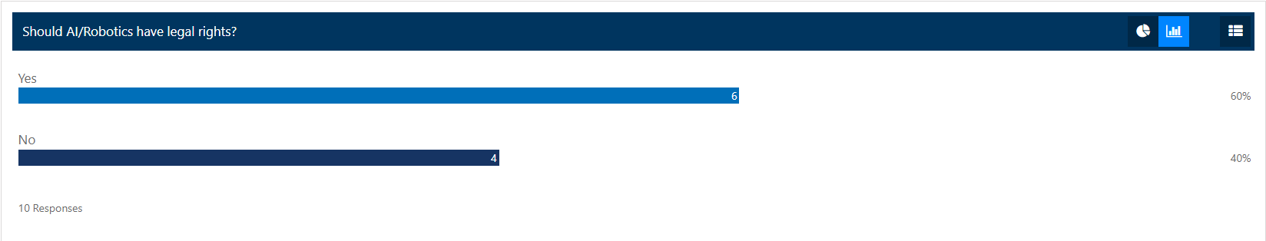
Picture 1
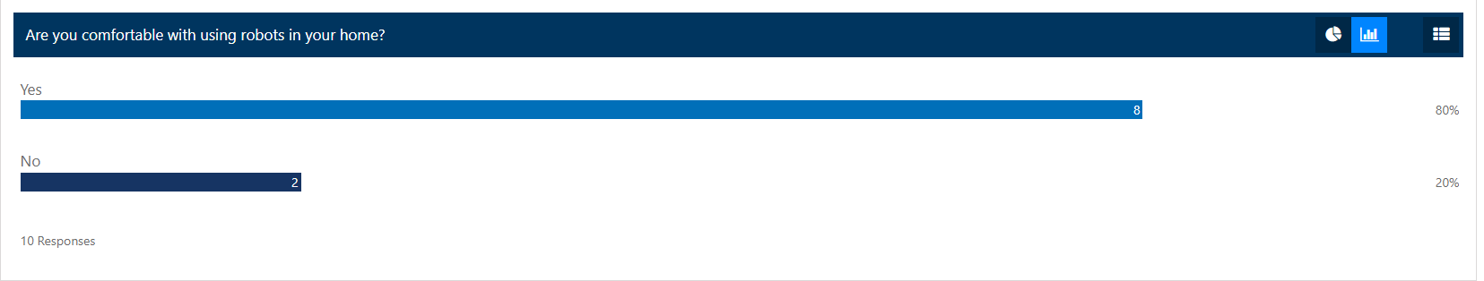
Picture 2
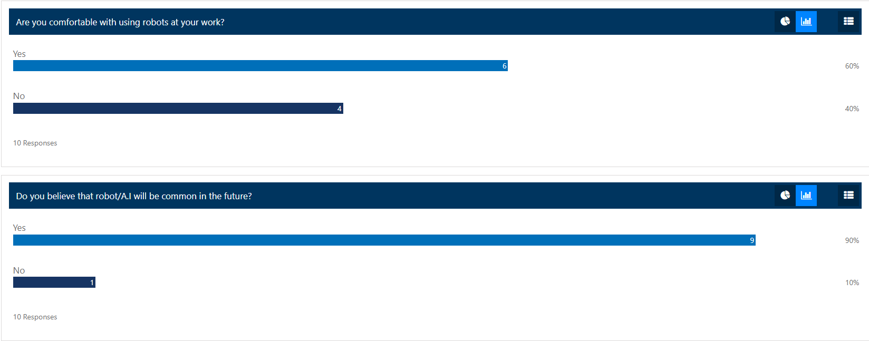
Picture 3
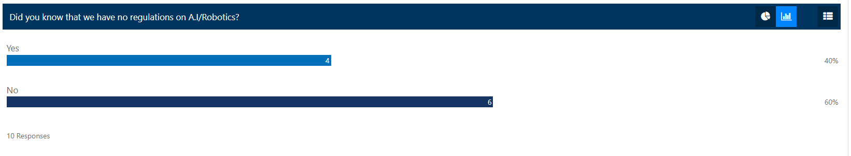
Picture 4
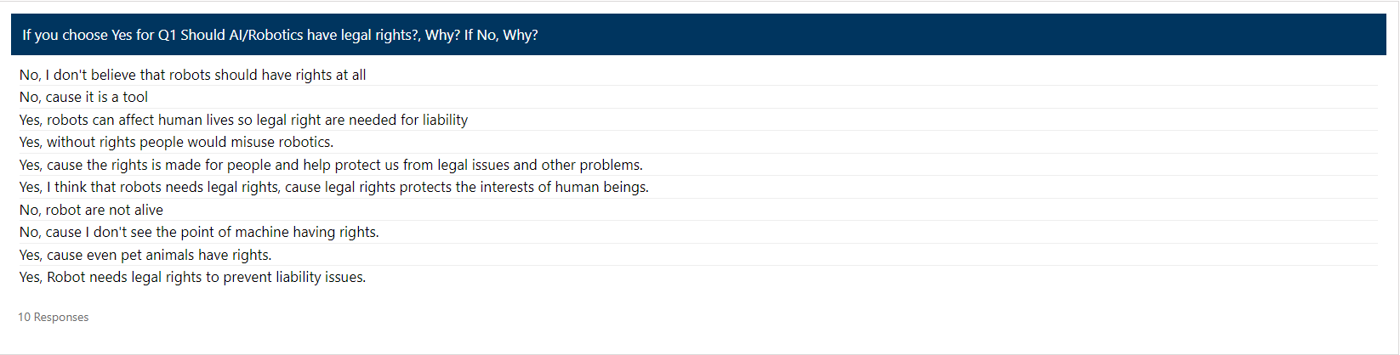
Picture 5
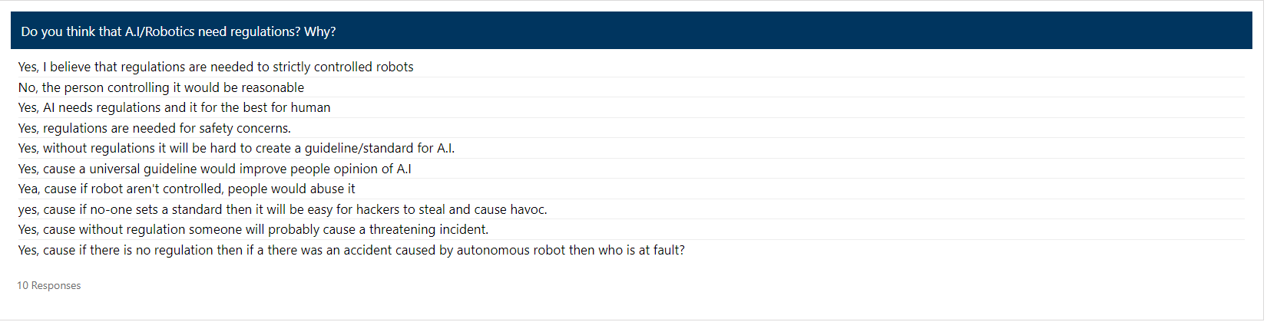
Picture 6
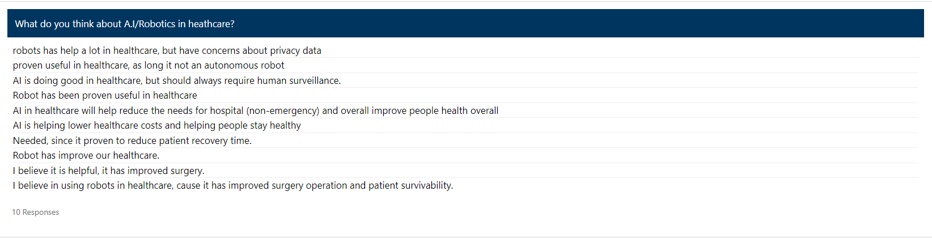
Picture 7

